Heuristic Evaluation of MemReprise
For a more in-depth overview of A9, please refer to the A9 assignment spec.

1. Problem/Prototype Description
MemReprise by Casey, Caroline, Kayla, Sophie is a mobile application for archiving, sharing, and discovering music and memorable associations such as emotions and activities.

2. Violations Found

Simple Task

1. H3: User Control & Freedom / Severity: 3 / Found by: A
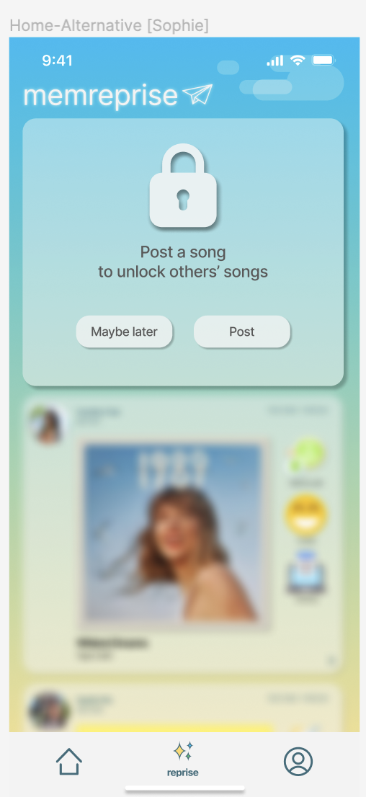
- Task: Simple: Share a Song on MemReprise
- Description: Post wall: users don’t have the freedom to view any content in the app without posting.
- Rationale: Incentivising users to post is a great way to spark engagement and generate content on the platform; however, users may feel like they lack freedom if there’s no way for them to view any content in the app without posting. A mix of the two could help support users’ freedom.
- Fix: Allow the user to view the Home and Profile tabs with older posts they’ve already received for greater freedom. Consider only withholding unseen posts behind the post wall until they post their own rather than all in-app content (i.e. “You have 2 new posts, post a song to unlock”).
Change: Users can still see old posts without posting but can’t see new posts.
- Unblur 2 (older) posts in original post screen and change prompt to “Post a song to unlock more posts from others”
- Add partition labeled “Older posts”
Assumption: that other users have already posted and they’re not the first ones posting.

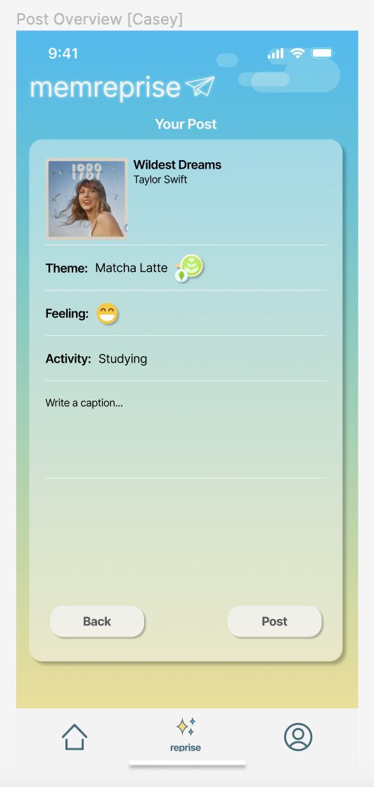
9. H1: Visibility of System Status / Severity: 3 / Found by: A
- Task: Simple: Share a Song on MemReprise
- Description: There should be an indication of privacy level and audience in the post preview before sharing.
- Rationale: Visibility of who a post will be shared with can be important for user privacy. Users may wonder if a post will be shared with all users on a platform, friends only, or just themselves. This can be especially important as current activity data could be combined with personal information mined separately to target the location of users without their consent and adversely impact vulnerable populations.
- Fix: Show the intended audience of a post before posting for visibility of who will be able to view its contents.
Change: Add privacy setting selection in “Finalize” post screen (Post Overview)
- Add privacy setting selection
- Add selection choices drop down (tentative placement: upper right corner)
  - Public, followers, friend groups

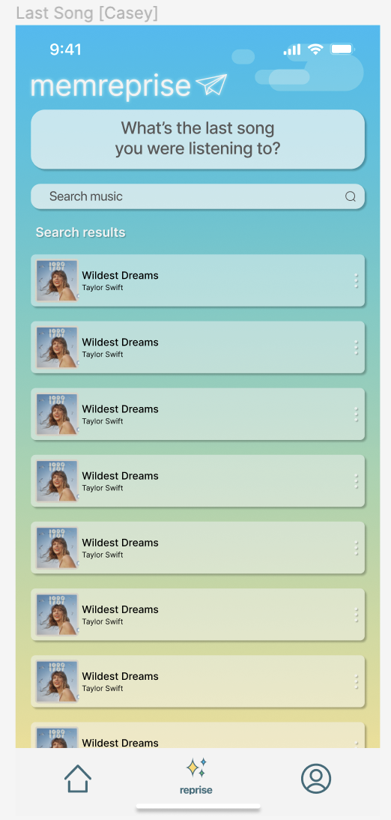
3. H6: Recognition Rather Than Recall / Severity: 3 / Found by: A
- Task: Simple: Share a Song on MemReprise
- Description: Requiring the user to search for the song they last listened to requires recall rather than recognition.
- Rationale: When prompted what the last song the user listened to was during the task flow, they’re required to recall from memory what was last. Depending on how long ago this was, it may be difficult for the user to remember. A recognition-based approach could reduce the cognitive load on the user by pulling the last song directly from their Now Playing history.
- Fix: Present the last / current song the user listened / is listening to from their Now Playing history as an option to support recognition rather than recall.
Change:
- Action Item (Casey): See if Spotify API “Recently Played Tracks” includes current song playing or not
  - Add a button: “Grab latest song from Spotify”
  - Keep search music feature: “Can’t find your song?” → search bar
  - If it does includes → use Casey’s currently implementation (triggers login to spotify and grabs the last played song from API)

38. H10 Help & Documentation / Severity: 3 / Found by: D
- Task: Simple: Sharing a song on MemReprise
- Description: The first screen on the prototype prompts the user to post a song but doesn’t explain to the user what is going on.
- Rationale: Users may get confused by the prompt and opt out of using the app entirely because of how abruptly they’re pushed into the experience.
- Fix: Onboarding to help flow of user experience
Change: Create onboarding screens
- Memreprise logo, then move upwards to show onboarding logo
  - Login
  - Signup
    - If choose sign-up, show them onboarding screens + option to skip
- Posting
  - “Answer question of the day”
  - “Select how you’re feeling”
  - “Select what you’re doing”
- View other’s associations
  - “See other people’s posts”
- Reprise
  - “Create customized playlists based on your associations”

4. H4: Consistency & Standards / Severity: 2 / Found by: A
- Task: Simple: Share a Song on MemReprise
- Description: Headers and labels can clarify the information hierarchy to help users understand the interface.
- Rationale: The post content screen has the title ‘Your Post’, a preview of the post in one bubble, and a sample prompt in another identical bubble. The alignment of the post preview and sample prompt under one header with the same style background bubbles makes them both seem like they contain content that will appear in the post; however, the question prompt is directed toward the user and not part of the post’s content. Additional headers and labels could clarify the information hierarchy for users. This has the added benefit of making the screen more accessible via screen readers (H11).
- Fix: Clarify the information hierarchy by adding titles for the post preview, question prompt, and response. Consider changing the background of the question prompt to clarify it’s the prompt and not appearing in the post directly.

5. H5: Error Prevention / Severity: 2 / Found by: A
- Task: Simple: Share a Song on MemReprise
- Description: Users can advance without making a selection.
- Rationale: When associating an activity with a song, users can click the right arrow button to advance to the next screen without selecting an activity.
- Fix: Display an error message if users attempt to advance to the next screen before inputting their required activity. (Better yet - see proposal in #6).

6. H7: Flexibility and Efficiency of Use / Severity: 2 / Found by: A
- Task: Simple: Share a Song on MemReprise
- Description: System should auto advance after a user makes a selection to streamline task flow.
- Rationale: After choosing a drink, the selection is nicely highlighted with a bright border in a visible way. Here, the system should auto advance to the next question rather than requiring users to click the small right arrow button on the bottom right. This not only streamlines the set of interactions throughout the task flow for all users but reduces confusion for novice users that the additional step of clicking the right arrow button on the bottom right needs to be done to advance.
While sometimes additional confirmation can be helpful to avoid unintended selections, users have multiple opportunities to go back to change their response as well as an opportunity to review and confirm before their final post, so these additional confirmation steps seem unnecessary.
- Fix: Advance to the next question in the new post flow after the user makes a selection without requiring an additional confirmation.
11. H4: Consistency & Standards / Severity: 2 / Found by: A
- Task: Simple: Share a Song on MemReprise
- Description: It’s unclear that the user can type a caption in the post preview area.
- Rationale: Users may not know that they can type a caption in the section with text ‘Write a caption…’ on the post preview without it being displayed in a text box.
- Fix: Add a textbox field with ‘Enter a caption…’ as filler text for clarity.

12. H11: Accessible Design / Severity: 2 / Found by: A
- Task: Simple: Share a Song on MemReprise
- Description: Let users input text by speaking instead of solely typing.
- Rationale: Adding a dictation button in text entry fields such as the Search and Add a Caption fields enables users to choose speaking as their preferred input method over typing. Speaking can be much easier for certain users than typing.
Fix: Add a dictation button in the text entry fields for Search and Add a Caption.

7. H8: Aesthetic & Minimalist Design / Severity: 1 / Found by: A, B
- Task: Simple: Share a Song on MemReprise
- Description: Excitement emoji and matcha latte icon in the post preview are different sizes.
- Rationale: Users may be confused about whether different sized icons have different implications for their post. If all associations within a post are equal, they should be displayed at the same size for consistency.
- Fix: Present song association icons in post preview at consistent sizes.

8. H4: Consistency & Standards / Severity: 1 / Found by: A
- Task: Simple: Share a Song on MemReprise
- Description: ‘Studying’ on the post preview should have an icon for consistency.
- Rationale: Users may be confused as to why some answers have associated icons with text, others have icons only, and others have text only. Representing all consistently can reduce confusion and reduce unnecessary diversion of user attention.
- Fix: Represent theme, feeling, and activity responses in the summary post preview consistently (icons only, text only, or icons + text for all).

2. H4: Consistency & Standards / Severity: 1 / Found by: A
- Task: Simple: Share a Song on MemReprise
- Description: Platform conventions for search bars have the search bar icon on the left before ‘Search’ rather than on the right.
- Rationale: Most users read left to right (the icon & all text could flip right to left when localized for Arabic & Hebrew). This also has the added benefit of making space for a dictation icon (see #12).
- Fix: Shift search icon to left side of search bar before ‘Search’.

10. H12: Value Alignment & Inclusion / Severity: 0 / Found by: A, C
- Task: Simple: Share a Song on MemReprise
- Description: Inability for users to personalize responses to themes, feelings, or activities.
- Rationale: The current set of four responses to the themed question, feelings, and activities may encompass the set of responses users in certain demographics may relate to, but unintentionally exclude others. For example, lemonade, hot chocolate, and matcha lattes may be very common and relatable in the US, but not in other regions.
- Fix: Consider broadening the set of allowed responses to be inclusive of responses relatable to a diverse audience and/or include the option for a custom response, which design team have alluded to earlier

33: H8: Aesthetic & Minimalist Design / Severity: 1 / Found by: B
- Task: Simple: Sharing a song on MemReprise
- Description: Unnecessary white space on song icon
- Rationale: The icons for a song and artist are quite large and have a lot of unnecessary whitespace.
- Fix: Increase font size or make icons smaller.

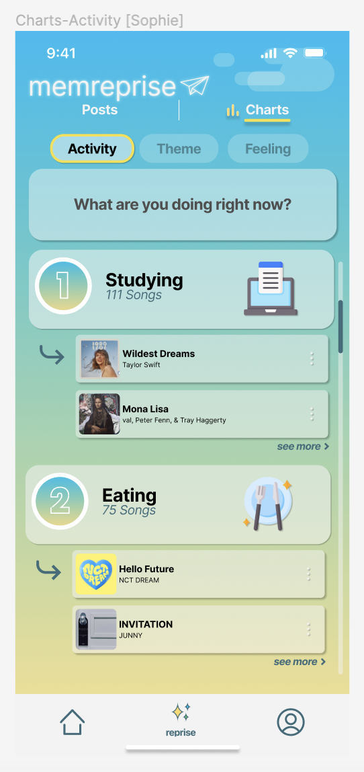
Moderate Task

13. H2: Match b/w System & Real World / Severity: 3 / Found by: A
- Task: Moderate: Discover Music From Other Users Who Have Similar Music Associations
- Description: Unclear that Charts was the place to go to discover music
- Rationale: Charts may refer to the way music associations are displayed, but may not be how the user would relate to discovering music from others.
- Fix: Rename ‘Charts’ to a term that may be natural and logical to the user for completing the new task such as ‘Discover’.
Change:
- Rename tab to Discover + compass
- Add a text label: “Top Responses”
- Fill in the number in the icon

15. H11: Accessible Design / Severity: 3 / Found by: A, B, C, D
- Task: Moderate: Discover Music From Other Users Who Have Similar Music Associations
- Description: Text size for artist names, user names, post dates, and captions on posts throughout this task flow are very small.
- Rationale: The user may have difficulty reading content as-is without in-app or system zoom.
- Fix: Increase font size of very small fonts for artist names, user names, post dates, and captions throughout task flow.
Change: make text bigger—standardize font sizes across the app—note down on our “stylesheet” docs

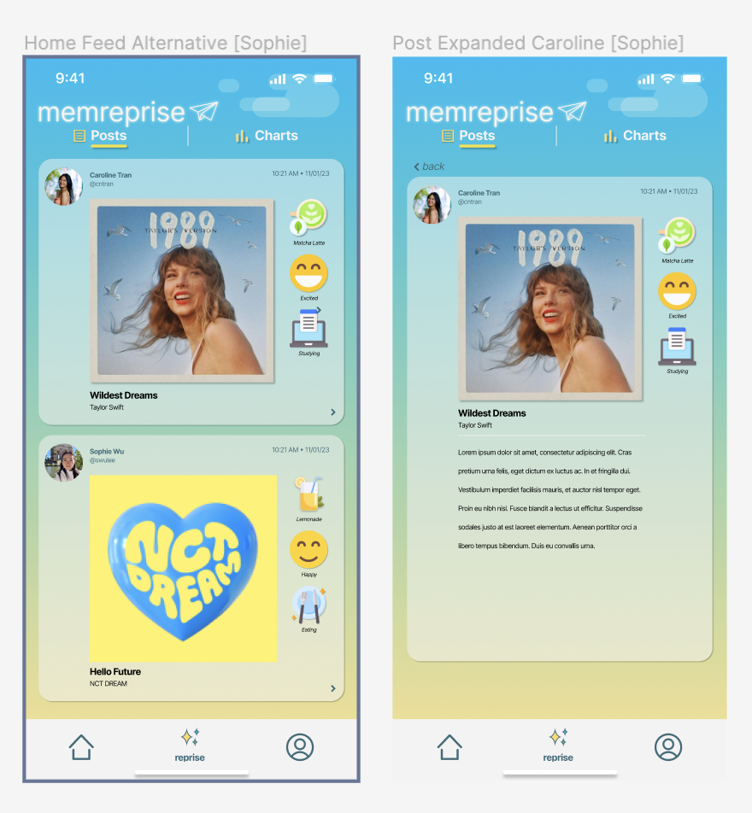
17. H11: Accessible Design / Severity: 3 / Found by: A, B
- Task: Moderate: Discover Music From Other Users Who Have Similar Music Associations
- Description: Give all controls and interactive elements a hit target that’s large enough.
- Rationale: On mobile applications, a hit target should measure at least 44x44 pt. Throughout the task flow, the ‘< back’ and ‘> see more’ elements have targets that are under this size and may be difficult to hit. Users with limited mobility need larger hit targets to help them interact with your application.
- Fix: Increase the hit targets for controls and interactive elements such as ‘< back’ and ‘> see more’ to be at least 44x44 pt.
Change: make hit targets (forward/back/expand) buttons bigger—standardize across the app, note down in our stylesheet

37: H8: Aesthetic & Minimalist Design / Severity: 2 / Found by: C
- Task: Moderate: Discover Music From Other Users Who Have Similar Music Associations
- Description: On the posts while exploring community music associations, album covers feel like the main focus, when it seems the main focus should be more on the name of the song, the caption, and the things associated with it. The album cover size is extremely large and all of the other information is extremely small.
- Rationale: Focusing on the album cover over all of the other information about the post seems like it may contrast with the purpose of the app, which is to name songs and provide associations.
- Fix: Slightly redesign the posts to focus more on the relevant information that you want the user to take away from the post.

14. H6: Recognition Rather Than Recall / Severity: 1 / Found by: A
- Task: Moderate: Discover Music From Other Users Who Have Similar Music Associations
- Description: The user may not remember which songs were their recommendations in the Charts view versus which were other users’ recommendations.
- Rationale: The user is forced to recall which songs they posted over time that may be associated with various responses (or that an arrow indicates that a song was their own). If users want to complete the task of discovering music from others, it’s important for them to be able to differentiate between which songs presented are from others.
- Fix: Text label for songs that were posted by the user.

16. H8: Aesthetic & Minimalist Design / Severity: 1 / Found by: A
- Task: Moderate: Discover Music From Other Users Who Have Similar Music Associations
- Description: Icon next to ‘Posts’ header disappears upon clicking ‘Charts’ header.
- Rationale: The icon next to ‘Posts’ header should remain present whether the ‘Posts’ section is selected or not. The disappearance of this minor aesthetic detail could be distracting to users.
- Fix: Keep posts icon next to ‘Posts’ section header regardless of whether the section is selected or not.

Complex Task

18. H2: Match b/w System & Real World / Severity: 3 / Found by: A, C, D
- Task: Complex Task: Create Personalized Playlist From Songs You Previously Shared
- Description: Reprise in ‘My Reprise’ may not be well known to users.
- Rationale: Reprise in ‘my reprise’ may not be well known to users. This is particularly difficult for non-native English speakers who use the application. From Google’s ngram viewer, here are a few comparisons between reprise and more its synonyms for insight into real world usage and familiarity:
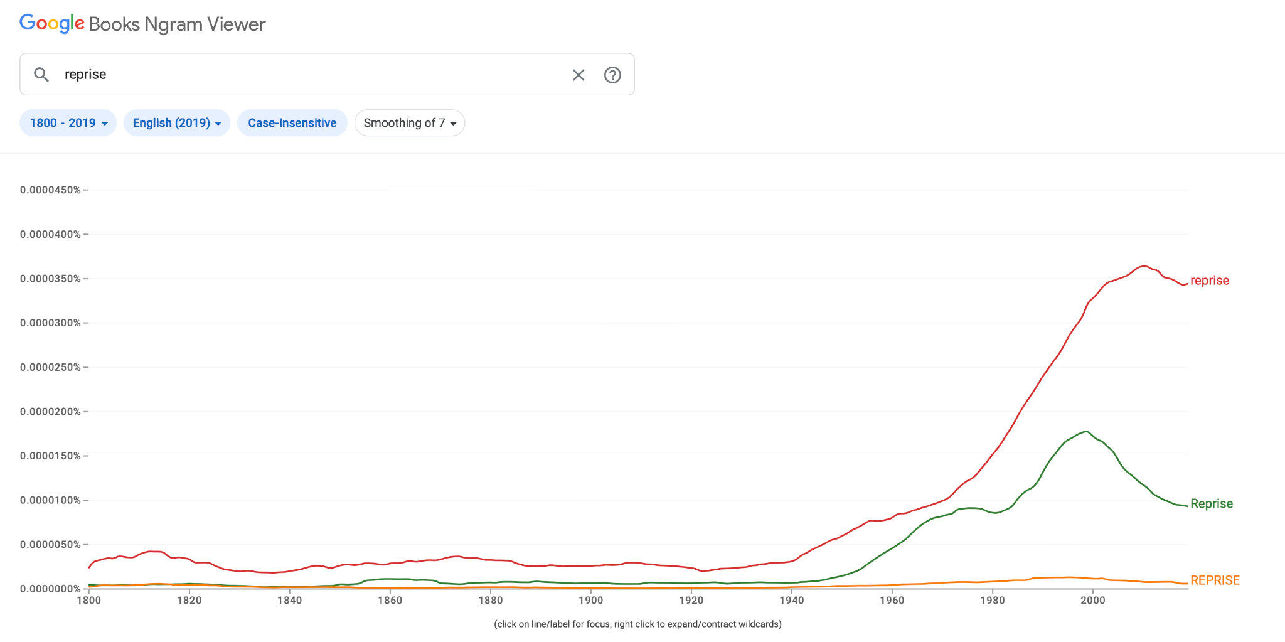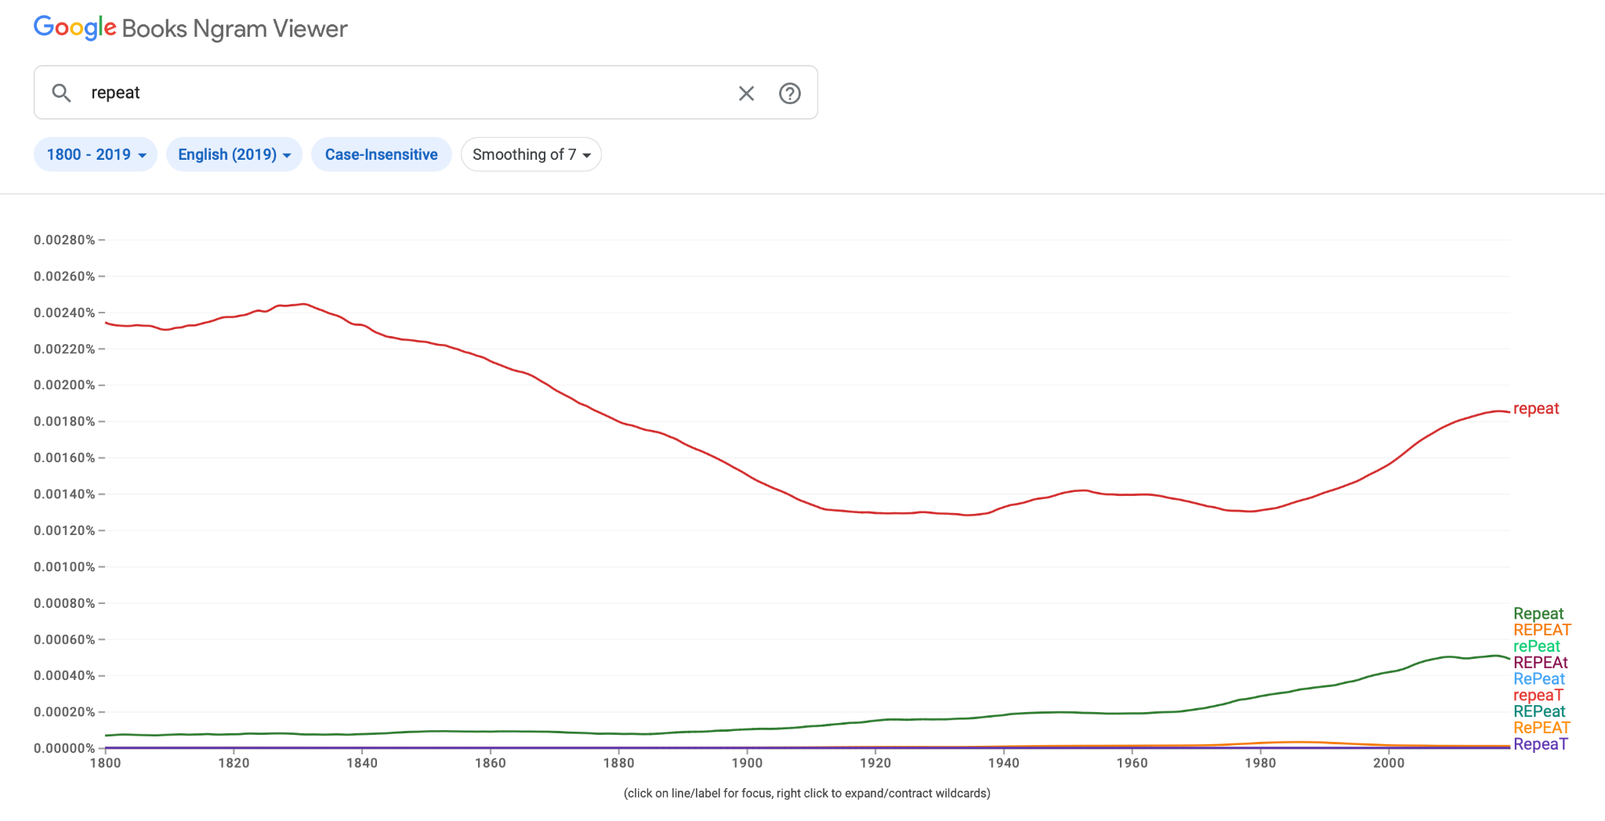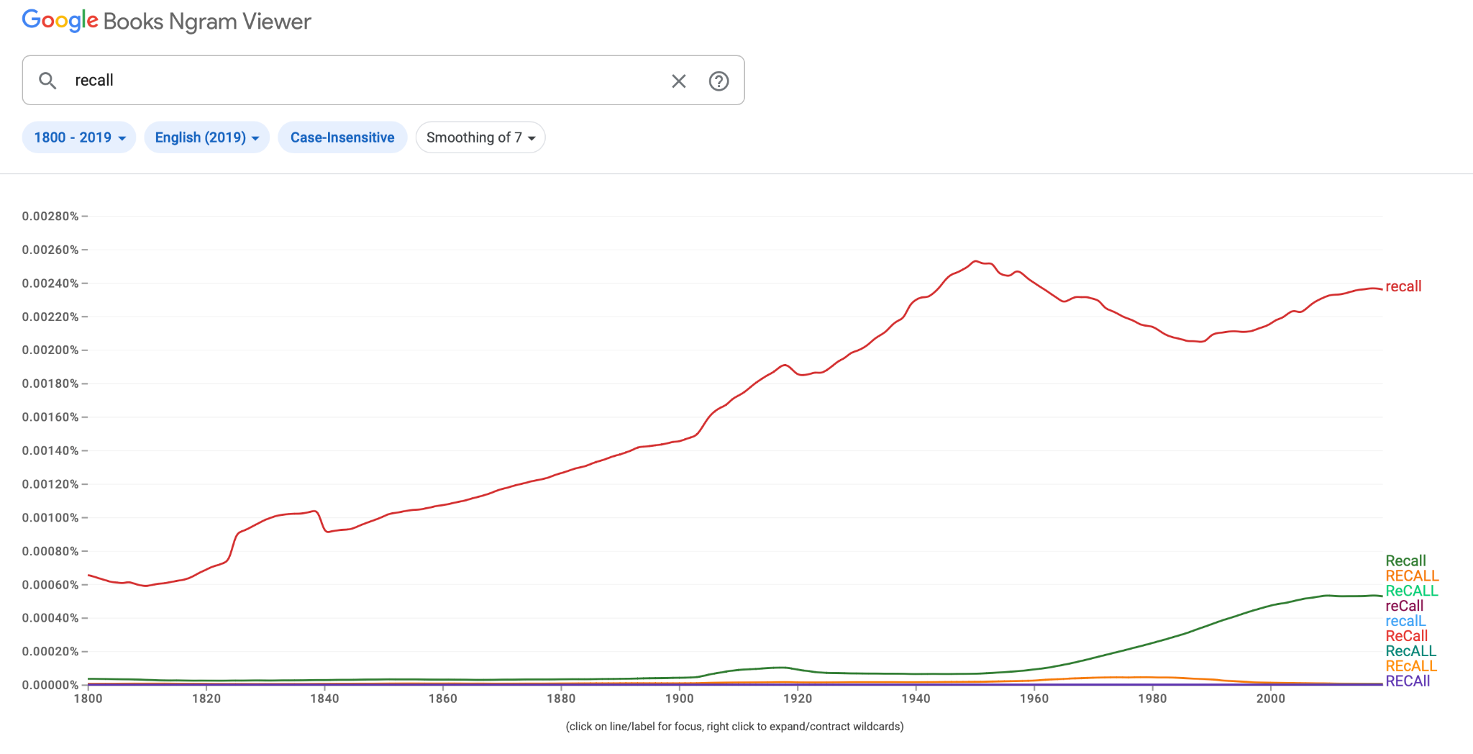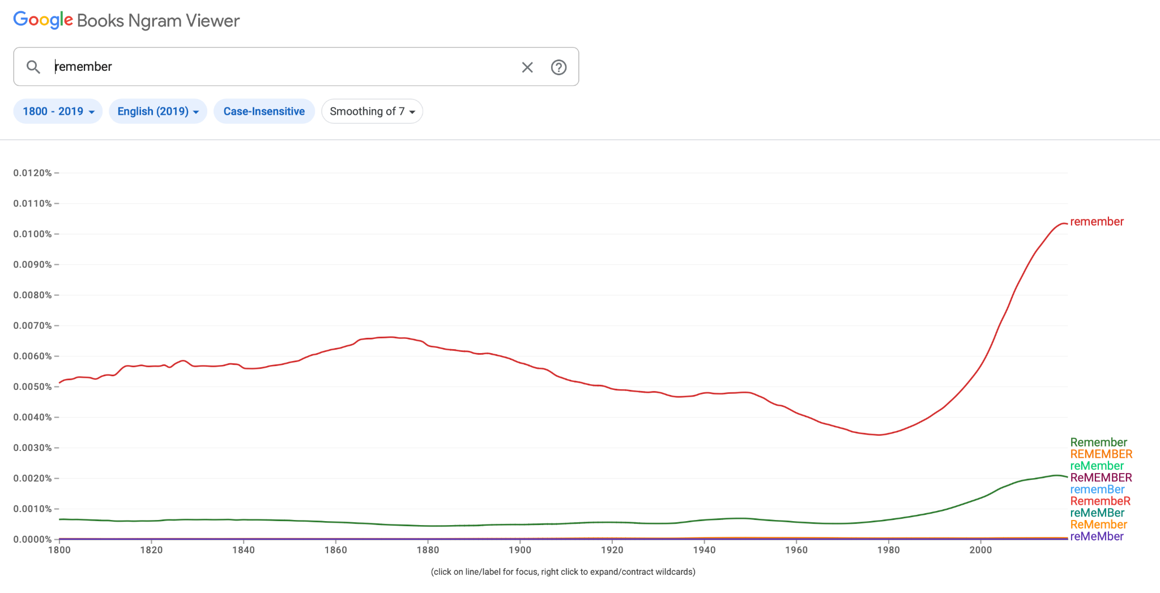
- Fix: If reprise is crucial to the branding of the app, consider defining it explicitly for users (also H10). Otherwise more common and familiar synonyms could be helpful for all users to understand.
Change:
- (See onboarding screens—will also try explicitly defining “reprise” there)
- Alternatives:
  - Memories
  - Replay

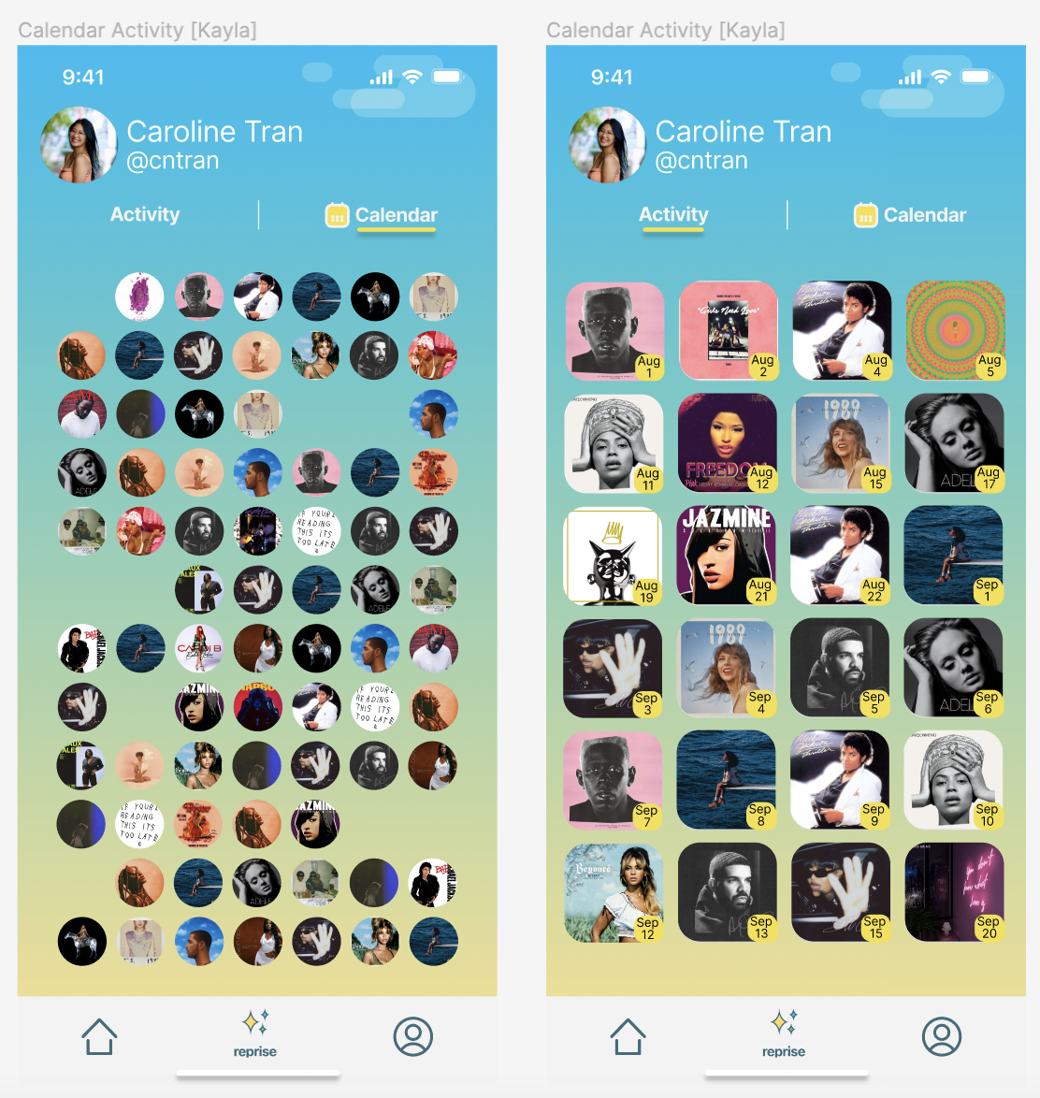
22. H8: Aesthetic & Minimalist Design / Severity: 3 / Found by: A, B, C, D
- Task: Complex Task: Create Personalized Playlist From Songs You Previously Shared
- Description: Calendar view of activities is unclear.
- Rationale: The Calendar view of activities doesn’t have a clear format or organization indicative of a time sorted view. Icons also lack dates making and months. This could cause confusion for users and increase their cognitive load trying to navigate it.
- Fix: Add labels to clarify how the songs are organized in a meaningful way or remove the Calendar tab view in favor of the Activity view being the sole view for clarity. If keeping the Calendar view, add dates and months for clarity.
Change: Add a month title, day of the week label, and numbered days of the month overlaid with circles
- Separate by months
- Get rid of calendar

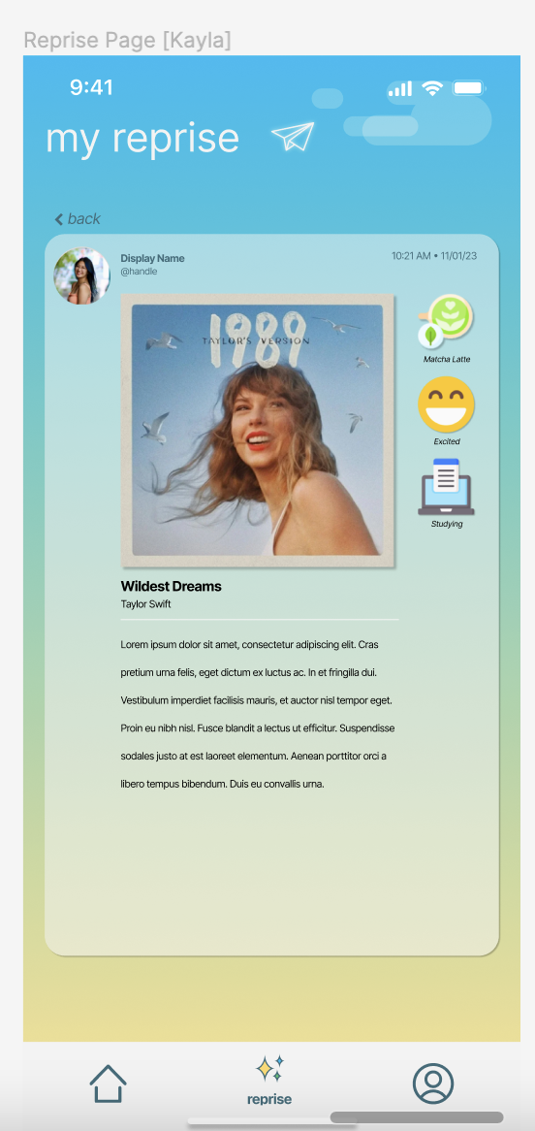
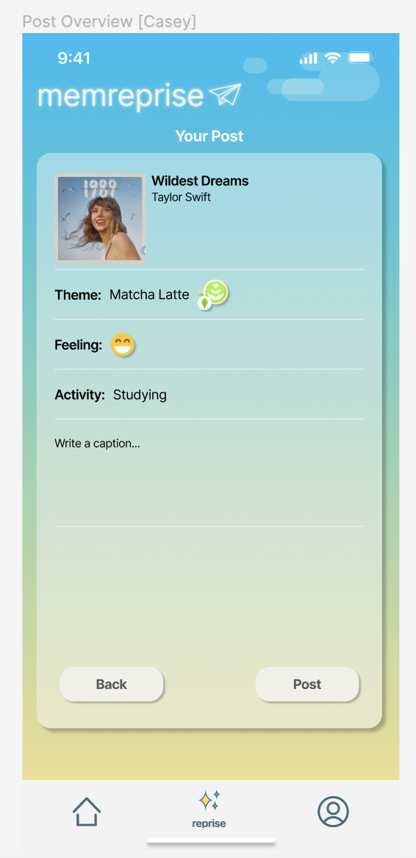
30. H3: User Control & Freedom / Severity: 3 / Found by: A
- Task: Extra
- Description: Users cannot delete posts.
- Rationale: Once a user posts a reprise, they don’t seem to have an option to delete it. They may want control of being able to undo a post they previously posted to unassociate it with their profile.
- Fix: Allow the user to delete their previous posts.
Change:
- “Cancel” or “X” button with “Are you sure you want to delete this post?” confirmation (Pop-up)—get rid of a post “in progress”/draft post
- “Delete Post” button with “Are you sure you want to delete your post?” confirmation (Pop-up), for option to delete it later

40. H7: Flexibility and efficiency of use / Severity: 3 / Found by D
- Task: Extra
- Description: User is only able to access reprise on certain pages
- Rationale: Users can’t efficiently access features on the app if only available on certain pages and users aren’t aware why
- Fix: Add tab bar to all screens so users can easily navigate.
Change:
- Ensure “wiring”/navigation leads to Reprise pop-up everywhere (?)
- Fix “filter” options—activity and feelings
- Alternative: Filter in “separate” screens, similar to posting mechanism

3. Summary of Violations
A Google Sheet Template is provided here to help you calculate numbers.

19. H2: Match b/w System & Real World / Severity: 2 / Found by: A
- Task: Complex Task: Create Personalized Playlist From Songs You Previously Shared
- Description: Export is a system term and not related to the real world.
- Rationale: ‘Export’ is a system term that may not relate to the user and real world conventions. Terms like ‘Add to Playlist’ or ‘Listen Now’ may be more relatable to the user and the task.
- Fix: Rename ‘Export’ to ‘Add to Playlist’ or ‘Listen Now’.

20. H7: Flexibility & Efficiency of Use / Severity: 2 / Found by: A
- Task: Complex Task: Create Personalized Playlist From Songs You Previously Shared
- Description: Export functionality should be tailorable.
- Rationale: Upon adding songs to a 3rd party music application playlist from MemReprise, the user may want to choose which specific songs to export or not. They may also want the option to either add them to a playlist or to their up next.
- Fix: Allow export by selection and specify whether the user can add songs to a playlist or to their listening queue.
- Fix: Rename ‘Export’ to ‘Add to Playlist’ or ‘Listen Now’.

21. H4: Consistency & Standards / Severity: 1 / Found by: A
- Task: Complex Task: Create Personalized Playlist From Songs You Previously Shared
- Description: Reprise tab icon uses stars but reprise popup icon uses a paper airplane icon instead.
- Rationale: A consistent icon for reprises may help users learn and associate them consistently. This can also reduce confusion users may have otherwise.
- Fix: Use paper airplane icon or stars icon consistently to represent reprises.

23. H8: Aesthetic & Minimalist Design / Severity: 1 / Found by: A
- Task: Complex Task: Create Personalized Playlist From Songs You Previously Shared
- Description: Selection arrow misalignments on My Generated Reprises view.
- Rationale: Right arrow buttons on all selectable songs should be aligned. Users may become distracted by slight misalignments of buttons in the column.
- Fix: Align all right arrow buttons in column on My Generated Reprises view.

24. H8: Aesthetic & Minimalist Design / Severity: 1 / Found by: A
- Task: Complex Task: Create Personalized Playlist From Songs You Previously Shared
- Description: Degree of roundedness on corners of album icons should be the same.
- Rationale: The degree of roundedness on all album art in the column grid on the My Generated Reprises view should be the same. Users may become distracted by visual inconsistencies.
- Fix: Set the same degree of rounded corners of all album icons in the same column on the My Generated Reprises view.

34: H4 Consistency and standards / Severity: 1 / Found by: B
- Task: Complex: Generate your personalized reprise playlist.
- Description: In the example the user selects 3 days worth of filtering but it makes a playlist of only 7 songs.
- Rationale: This is a minor error in the medium-fidelity prototype.
- Fix: Change selection for 3 to 7.

35: H7 Flexibility and efficiency of use / Severity: 2 / Found by: B
- Task: Complex: Generate your personalized reprise playlist.
- Description: Time options include 3 days, 1 week, 1 month, 1 year.
- Rational: If we are already filtering out these songs through 2 different filters it’s likely these lists may end up being very short, so a playlist with only 3 songs may be useless, also the jump from 1 month to 1 year seems huge, maybe a middle ground option like 4 months would be more useful?
- Fix: Add more or more evenly spread out options for time.

36: H5 Error prevention / Severity: 1 / Found by: B
- Task: Complex: Generate your personalized reprise playlist.
- Description: The export music screen includes a YouTube option
- Rationale: While other apps could support a playlist of songs, it’s not likely YouTube could since they use video files instead of songs.
- Fix: Remove YouTube from the export screen.
39. H4 Consistency and standards / Severity: 2 / Found by: D
- Task: Complex: Generate your personalized reprise playlist.
- Description: When interacting with the Reprise feature, the user selects reprise and is shown the list of past posts. My reprise page design isn’t consistent with the main page, so it’s hard to register that the songs shown are past posts.
- Fix: Make sure reprise feature is available from all screens where logo is visible.

All Tasks

25. H4: Consistency & Standards / Severity: 2 / Found by: A
- Task: All Tasks
- Description: Multiple variations of back buttons: left arrows with the text ‘< back’ on the top left (multiple screens) and buttons with the text ‘Back’ on the bottom left (post preview screen).
- Rationale: Navigational elements should be consistent throughout the UI for clarity and align with platform conventions / design guidelines.
- Fix: Consistent application of system provided ‘<’ navigational elements in the top upper left corner of screens with the optional text of the name of the previous screen.

32: H8: Aesthetic & Minimalist Design / Severity: 1 / Found by: B
- Task: All Tasks
- Description: The Memreprise logo at the top of the screen makes the screen feel cramped and cluttered
- Rationale: The logo probably doesn’t need to be in every screen beyond the first few.
- Fix: Removal of text (“MemReprise”) or removal of logo in its entirety.

Extra

26. H4: Consistency & Standards / Severity: 1 / Found by: A, C
- Task: Extra
- Description: Tab bar at the bottom should have icons & text for consistency and adherence to platform conventions.
- Rationale: Some tab titles have icons only whereas reprise has text and an icon. Per platform design guidelines, useful tab titles aid the user in navigating the application.
- Fix: Ensure all tabs have titles with the icons, or none have titles and make sure icons are intuitive enough without text

27. H1: Visibility of System Status / Severity: 1 / Found by: A
- Task: Extra
- Description: Tab bar at the bottom should indicate which tab the user is currently on.
- Rationale: The current tab the user has selected should be highlighted so users are informed as to which tab they’re currently in.
- Fix: Incorporate a lighter contrast text and icon color for the tab that’s currently selected by the user for visibility.

28. H1: Visibility of System Status / Severity: 1 / Found by: A, C
- Task: Extra
- Description: Unclear how songs are ordered in the profile tab’s calendar view.
- Rationale: Viewing all content without any indication as to what the meaning of the ordering is can make it difficult for users to understand. Clear labels specifying how the content is ordered (e.g. date / time) can improve visibility.
- Fix: Incorporate labels indicating how songs are ordered on a user profile tab’s calendar view (e.g. date labels).

31: H10: Help and Documentation / Severity: 1 / Found by: A, B, C, D
- Task: Extra
- Description: A high level help / tips page could assist users with key tasks.
- Rationale: There could be a high level documentation page that answers frequently asked questions or walks through onboarding steps. This could be especially useful for new users or vulnerable populations who may need assistance learning how to interact with key features.
- Fix: Incorporate a high level documentation / tips page.

29. H7: Flexibility & Efficiency of Use / Severity: 0 / Found by: A
- Task: Extra
- Description: Search and filtering by date, artist, song, theme, activity, or mood can expedite discovery of songs for all users in the profile tab’s calendar view.
- Rationale: Users may want to find songs that are associated with a specific emotion, activity, or time that can be greatly expedited by enabling search.
- Fix: Incorporate a search bar and filters onto the profile tab’s calendar view for ease of finding content the user cares most about.

Category | # Viol.  (sev 0) | # Viol.  (sev 1) | # Viol.  (sev 2) | # Viol.  (sev 3) | # Viol.  (sev 4) | # Viol. (total)
H1: Visibility of Status | 0 | 2 | 0 | 1 | 0 | 3
H2: Match Sys & World | 0 | 0 | 1 | 2 | 0 | 3
H3: User Control | 0 | 0 | 0 | 2 | 0 | 2
H4: Consistency & Standards | 0 | 5 | 3 | 0 | 0 | 8
H5: Error Prevention | 0 | 1 | 1 | 0 | 0 | 2
H6: Recognition not Recall | 0 | 1 | 1 | 1 | 0 | 3
H7: Efficiency of Use | 1 | 0 | 3 | 0 | 0 | 4
H8: Minimalist Design | 0 | 6 | 0 | 1 | 0 | 7
H9: Help Users with Errors | 0 | 0 | 0 | 0 | 0 | 0
H10: Help & Documentation | 0 | 1 | 0 | 0 | 0 | 1
H11: Accessible | 0 | 0 | 2 | 1 | 0 | 3
H12: Value Alignment & Inclusion | 1 | 0 | 0 | 0 | 0 | 1
Total Violations by Severity | 2 | 16 | 11 | 8 | 0 | 37
Note: check your answer for the green box by making sure the sum of the last column is equal to the sum of the last row (not including the green box)

4. Evaluation Statistics (in %)
Severity /  Evaluator | Evaluator A | Evaluator B | Evaluator C | Evaluator D
Sev. 0  Ex: Eval A count / total sevs 0 in table #3 | 1/2 = 50% | 0/2 = 0% | 1/2 = 50% | 0/2 = 0%
Sev. 1  Ex: Eval A count / total sevs 1 in table #3 | 68.75% | 37.5% | 17.6% | 6.25%
Sev. 2  Ex: Eval A count / total sevs 2 in table #3 | 100% | 9% | 9% | 9%
Sev. 3  Ex: Eval A count / total sevs 3 in table #3 | 100% | 37.5% | 27% | 50%
Sev. 4  Ex: Eval A count / total sevs 4 in table #3 | N/A | N/A | N/A | N/A
Total (sevs. 3 & 4)  Ex: Eval A = sum(sev 3: sev 4 counts) / sum(sev 3: sev 4 in table #3) | 100% | 37.5% | 27% | 50%
Total  (all severity levels)  Ex: Eval A total sev count / total sevs (green cell) in table #3 | 84% | 27% | 19.5% | 16.2%
*Note that the bottom rows are not calculated by adding the numbers above it.

5. Summary Recommendations
Overall, the goal of the MemReprise application is compelling and the medium-fidelity prototype was complete with all three key task flows. All screens were interactive and there were no UI catastrophes that would prevent users from accomplishing their tasks. A total of 37 heuristic violations across all areas except H9: Help Users with Errors were noted. Eight heuristic violations with a severity level of 3 were highlighted in the areas of H2: Match Between System & Real World, H3: User Control & Freedom, H6: Recognition Rather than Recall, H1: Visibility of System Status, H11: Accessible Design, and H8: Aesthetic & Minimalist Design. Given the higher severity, these eight are higher priority issues to address for immediate and highly impactful improvements in the user experience. Sample recommendations include being cognizant of terms that may be natural and logical to users for ease of navigation, ensuring hit targets for controls and interactive elements are sufficiently large, ensuring information hierarchy is clear and visible in all screens, and ensuring users have control and freedom to navigate rather than feeling stuck behind a post wall or being unable to delete past posts.
Eleven heuristic violations with a severity level of two were highlighted across H4: Consistency & Standards, H7: Flexibility & Efficiency of Use, H11: Accessible Design, H5: Error Prevention, H6: Recognition Rather than Recall, and H2: Match b/w System & World, and sixteen heuristic violations with a severity level of one were found across H1: Visibility of System Status, H4: Consistency & Standards, H5: Error Prevention, H8: Aesthetic & Minimalist Design, and H10: Help & Documentation. All have recommended fixes resulting in potential improvements in user experience through minimal changes before the high-fidelity prototype implementation. Additional enhancements not related to violations could include the ability to like posts to promote more engagement between users.
In performing the heuristic evaluation, there were also some excellent applications of great design that were notable. We loved the incorporation of the progress bar for visibility into the percent completion of the new post flow which helps users stay informed regarding how many questions they need to complete before they can share their post with others. Other notable incorporations of clearly visible status were details such as border highlights around selected responses during the post questionnaires.
The implementation of the medium-fidelity prototype was overall great and we’re looking forward to seeing what comes next from the team.

Severity Ratings
0 - not a usability problem
1 - cosmetic problem
2 - minor usability problem
3 - major usability problem; important to fix
4 - usability catastrophe; imperative to fix

Heuristics
H1: Visibility of System Status
- Keep users informed about what is going on

H2: Match Between System & Real World
- Speak the users’ language
- Follow real world conventions

H3: User Control & Freedom
- “Exits” for mistaken choices, undo, redo
- Don’t force down fixed paths

H4: Consistency & Standards
- Words, actions, and UI elements should be consistent across the entire platform
- Follow platform and industry conventions

H5: Error Prevention
- Minimize error-prone conditions
- Remove memory burdens, support undoing, and warn your users when necessary

H6: Recognition Rather Than Recall
- Make objects, actions, options, & directions visible or easily retrievable

H7: Flexibility & Efficiency of Use
- Accelerators for experts (e.g., gestures, keyboard shortcuts)
- Allow users to tailor frequent actions (e.g., macros)

H8: Aesthetic & Minimalist Design
- No irrelevant information. Focus on the essentials.

H9: Help Users Recognize, Diagnose, & Recover from Errors
- Error messages in plain language
- Precisely indicate the problem
- Constructively suggest a solution

H10: Help & Documentation
- Easy to search
- Focused on the user’s task
- List concrete steps to carry out
- Not too large

H11: Accessible
- Users can interact with the system using alternative input methods.
- Content is legible with distinguishable contrast and text size.
- Key information is upfront and not nested for screen readers.
- Purely visual or auditory content has text-based alternatives for users with low vision and low hearing.

H12: ​​Value Alignment and Inclusion
- The design should encode values that users can understand and relate to.
- It should make a diverse group of users feel included and respected.
- The design should prevent the reproduction of pre-existing inequities and not create additional burdens for members of disadvantaged populations.

